## Object-Oriented Programming Assignment Report

## BTech 4th Semester

## 2024 - 2025

**Project Title: Smart City Application**



**Submitted To**: Mr. Aryan Assistant Professor (SoCS)

**Submitted By:** Anurag Pandey 500120453

**Smart City Application**

**Abstract**

The rapid urbanization and technological advancements have led to the need for smart solutions to improve city infrastructure and enhance the overall quality of life. This project, **Smart City Application**, is designed to serve as an interactive guide for new visitors by providing crucial information about the city, including hotels, restaurants, shopping malls, tourist places, and transportation options. The application is developed using **Java Swing for the UI and MySQL for the database**, ensuring efficient data management and user-friendly navigation.

The system allows users to search for places based on location and displays relevant details such as contact information, pricing, opening hours, and ratings. The transportation module enhances user convenience by providing an interactive **cab-like booking system**. The project follows object-oriented programming (OOP) principles to ensure modularity and scalability.

By integrating technology with urban infrastructure, this application aims to streamline city exploration, making it easier for residents and visitors to access essential services. The future scope includes enhancing the application with real-time updates, GPS-based tracking, and additional smart city functionalities.

**Acknowledgment**

I would like to express my heartfelt gratitude to my **instructor**, whose invaluable guidance and constructive feedback have been instrumental in the successful completion of this project. Their insights into **Java programming, database management, and UI design** have significantly contributed to my learning experience.

I am also thankful to my **peers and classmates** for their continuous support and encouragement throughout the development process. Their suggestions helped in refining the application and making it more user-friendly.

Finally, I extend my appreciation to my **family and friends**, whose unwavering motivation kept me dedicated to completing this project efficiently. This journey has been a great learning experience, and I look forward to applying these skills in future smart city initiatives.

**Table of Contents**

|  |  |
| --- | --- |
| Sr. No | Title |
| 1 | Introduction |
| 2 | Flow Chart |
| 3 | UML Diagram |
| 4 | Software Requirements |
| 5 | Project Directory Structure |
| 6 | Code Snippets |
| 7 | Database Schema and Tables |
| 8 | Output Screenshots |
| 9 | Project Summary |
| 10 | Important Learnings |

# 1. Introduction

The Smart City Application is a Java Swing-based desktop application that serves as a digital city guide. It provides users with easy access to essential city services, making their navigation seamless.

Key Features:

• City Information: Overview of major landmarks and facilities.  
• Tourism Guide: Information about hotels, restaurants, and tourist attractions.  
• Transportation System: Allows users to find and book rides from different locations.  
• shopping malls: Provides details of malls, including their opening and closing times.  
• User-Friendly Interface: Interactive UI designed to enhance the user experience.

# 2. Flow Chart

# 

# 3. UML Diagram

# 

# 4. Software Requirements

Hardware Requirements:  
• Processor: Intel Core i3 or above  
• RAM: Minimum 4GB  
• Storage: Minimum 500MB  
  
Software Requirements:  
• Programming Language: Java (Swing for UI, JDBC for database connectivity)  
• Database: MySQL  
• IDE Used: IntelliJ IDEA Community Edition  
• Libraries: Swing, AWT, MySQL Connector/J  
• Operating System: Windows/Linux

# 5. Project Directory Structure

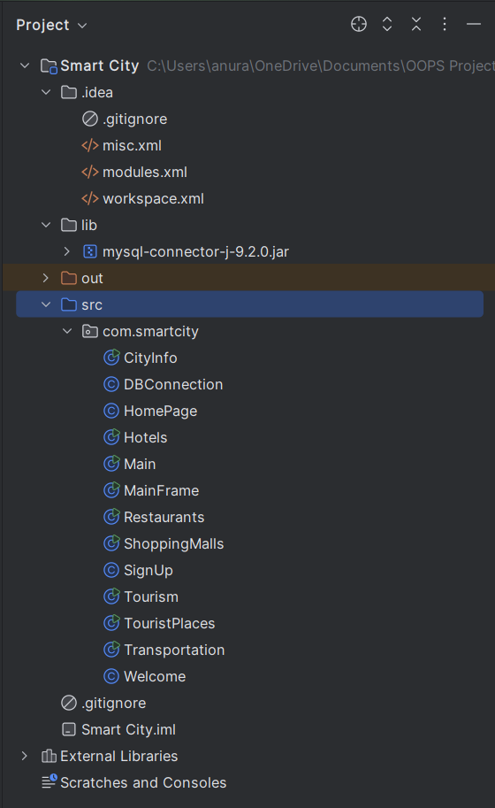

# 6. Database Schema and Tables

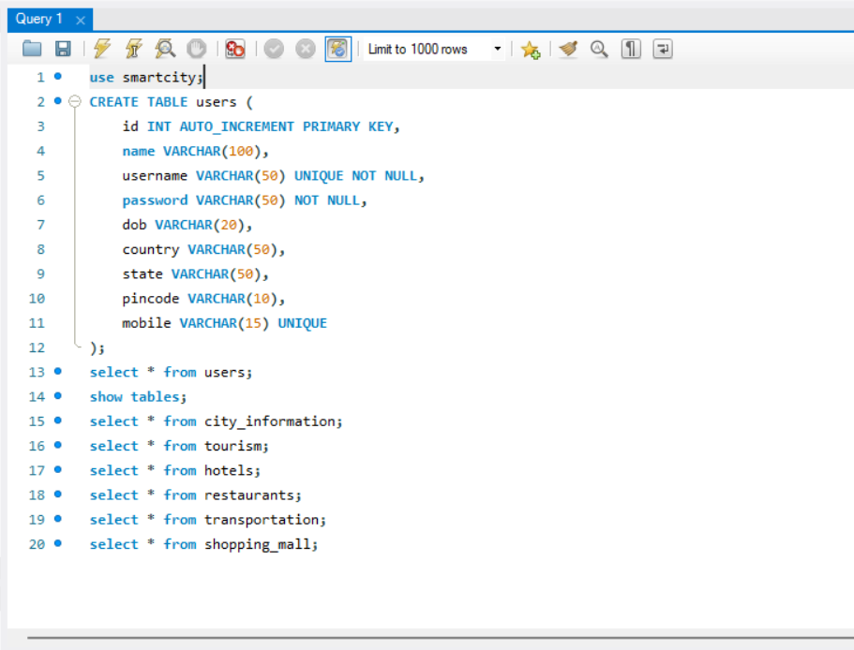

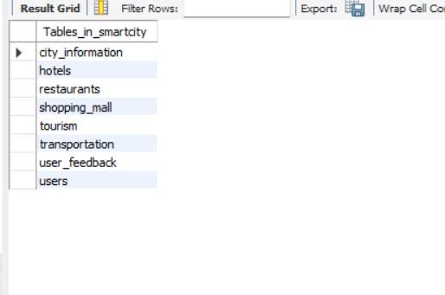

# 7. Code Snippets

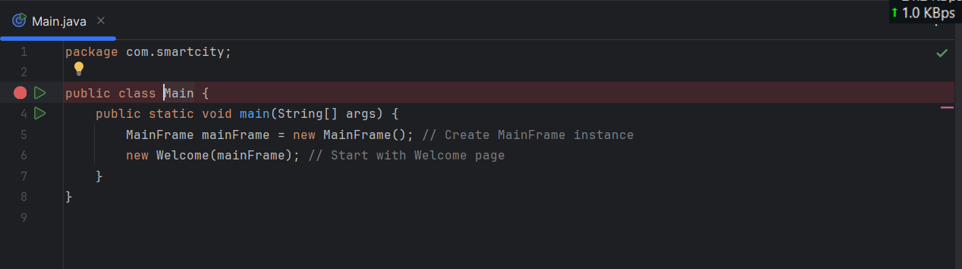

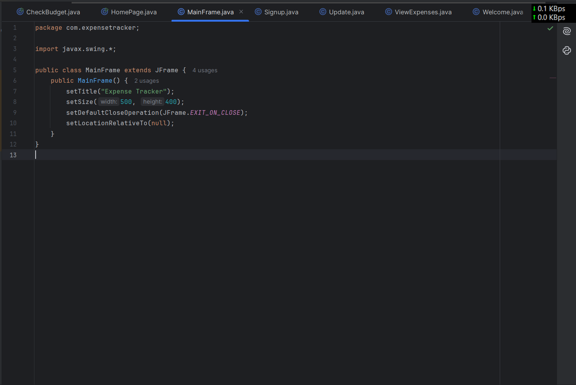

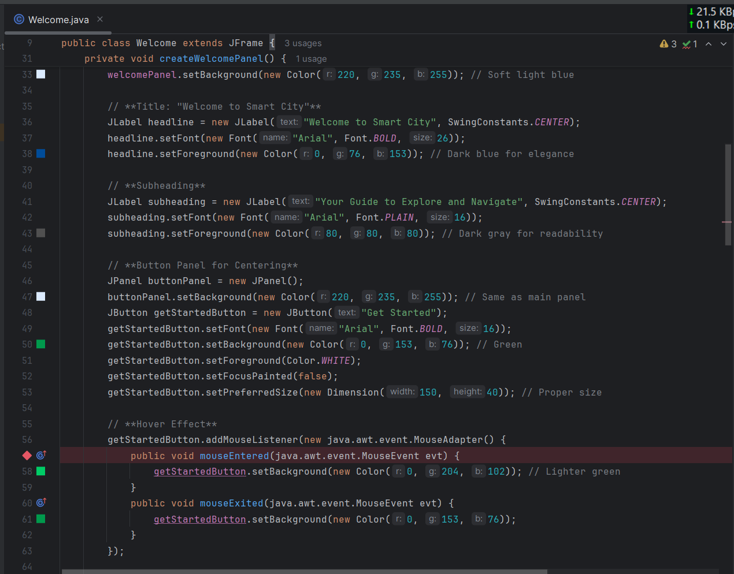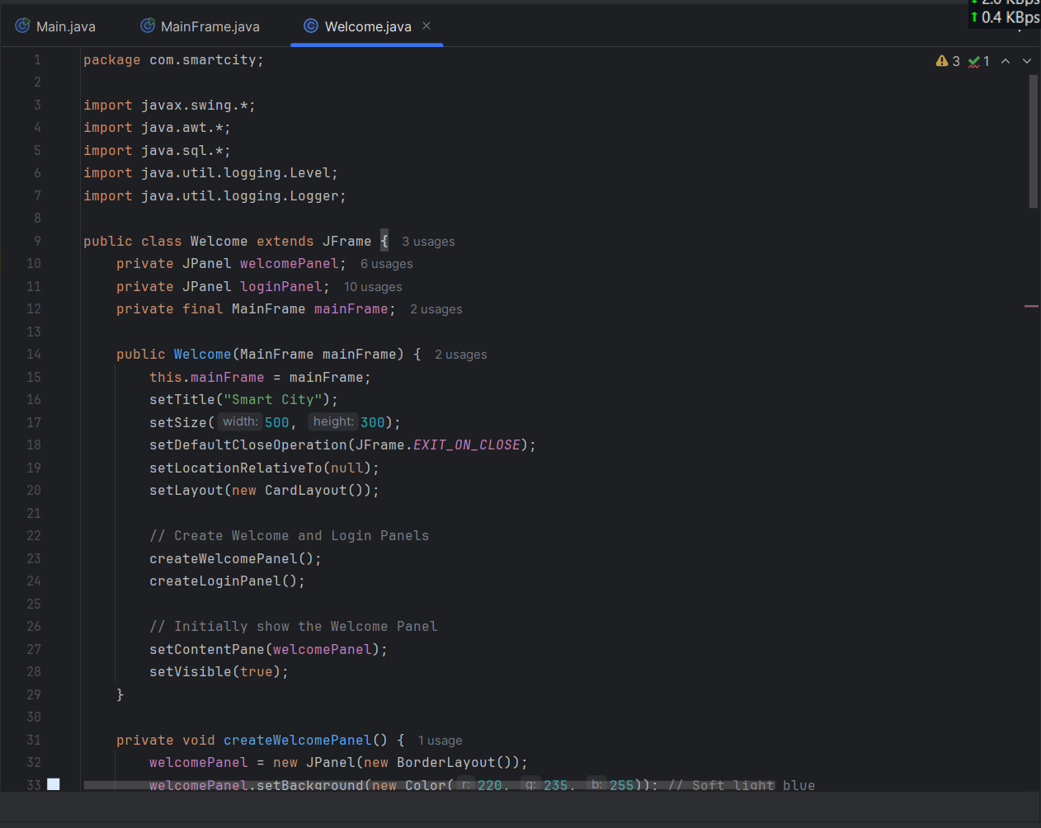

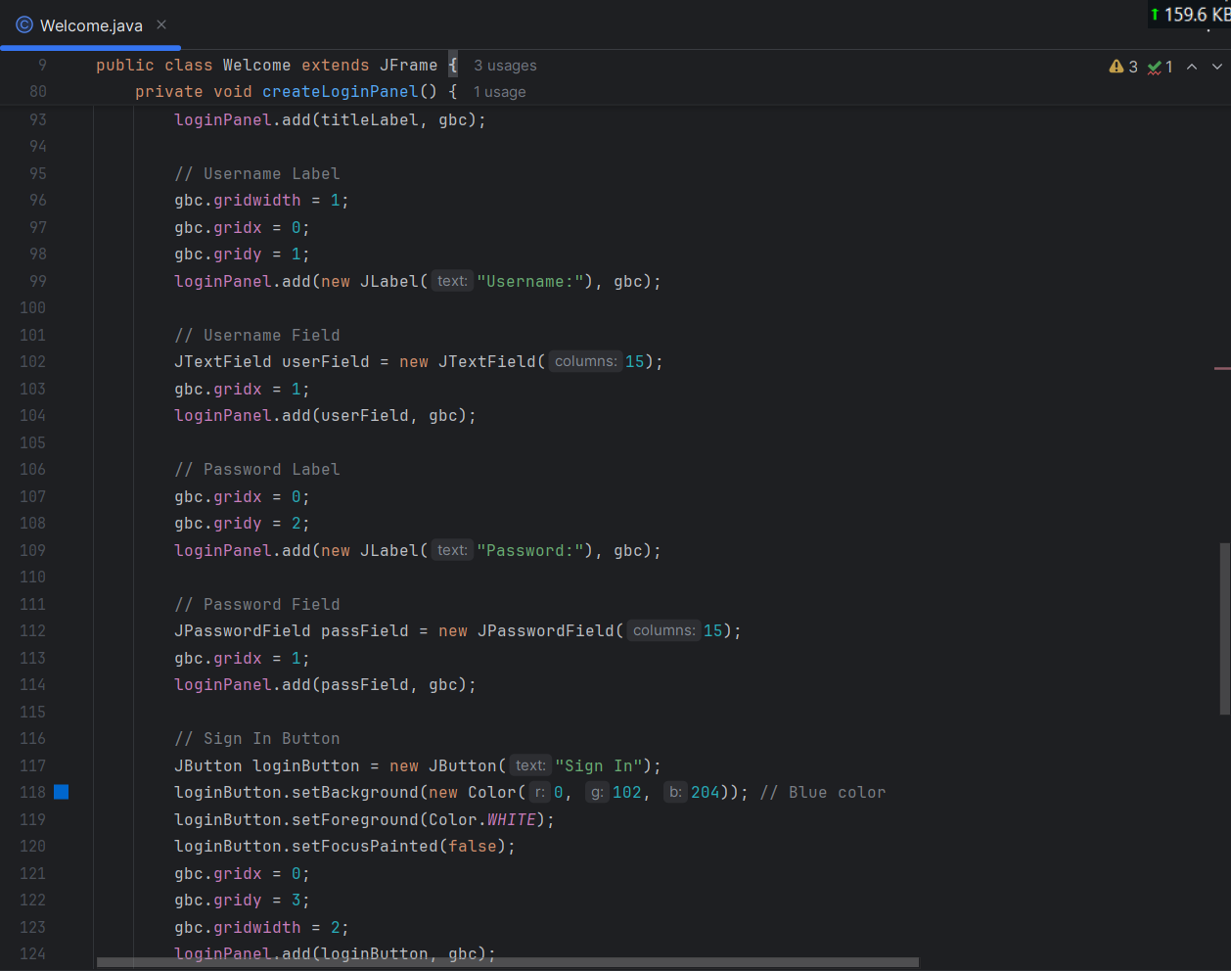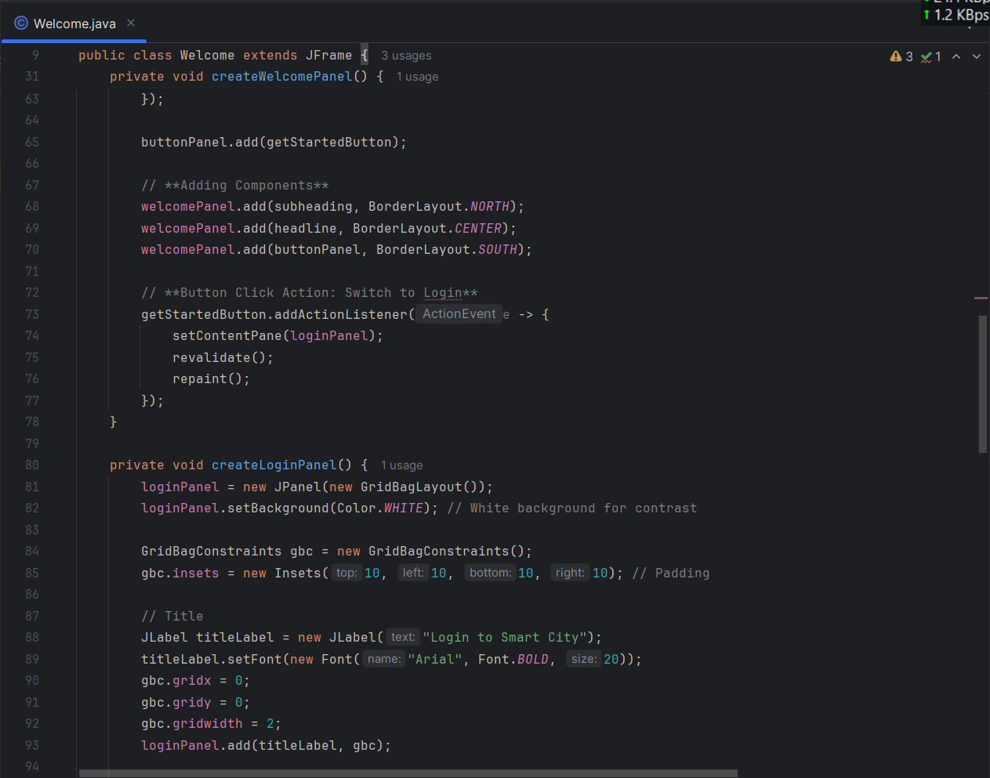

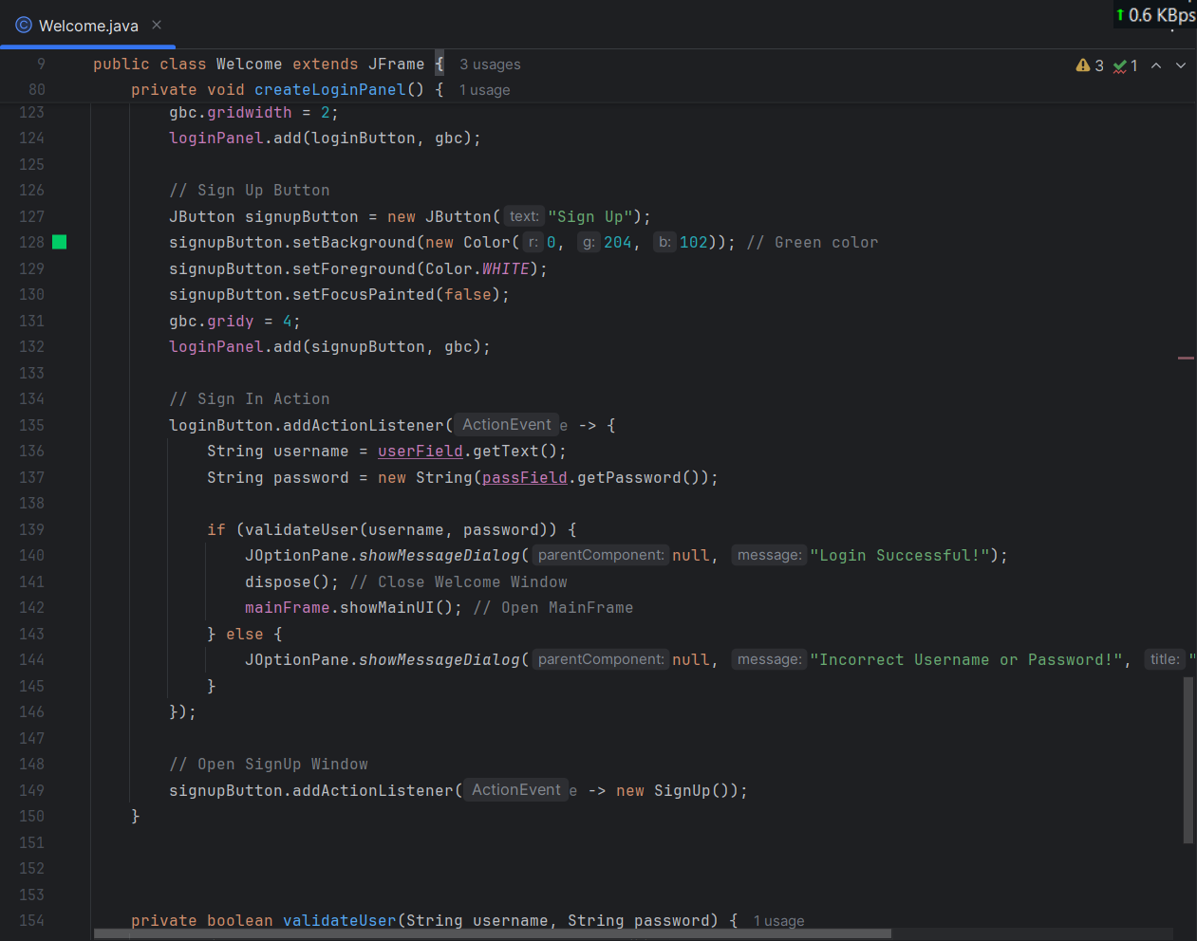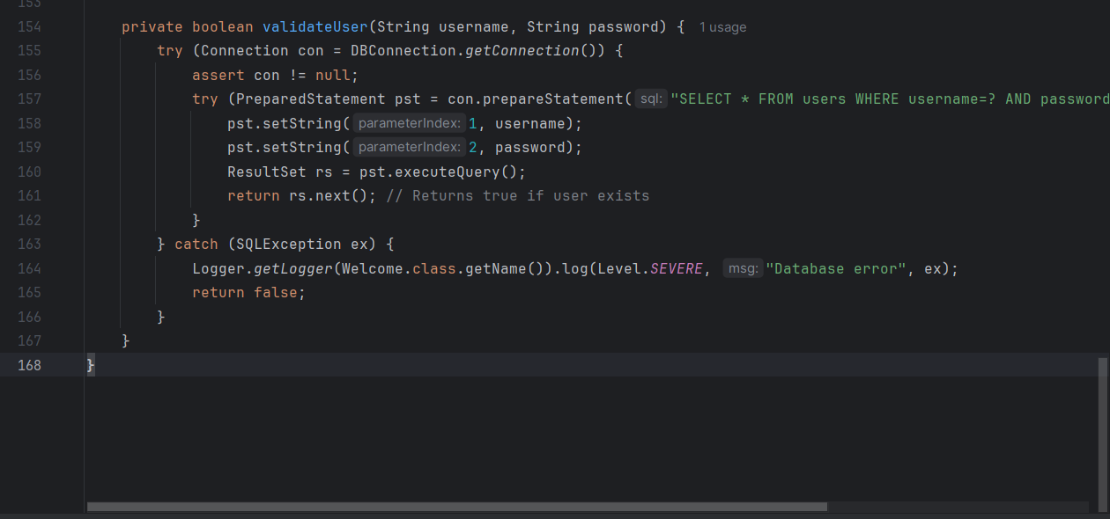

# 

# 

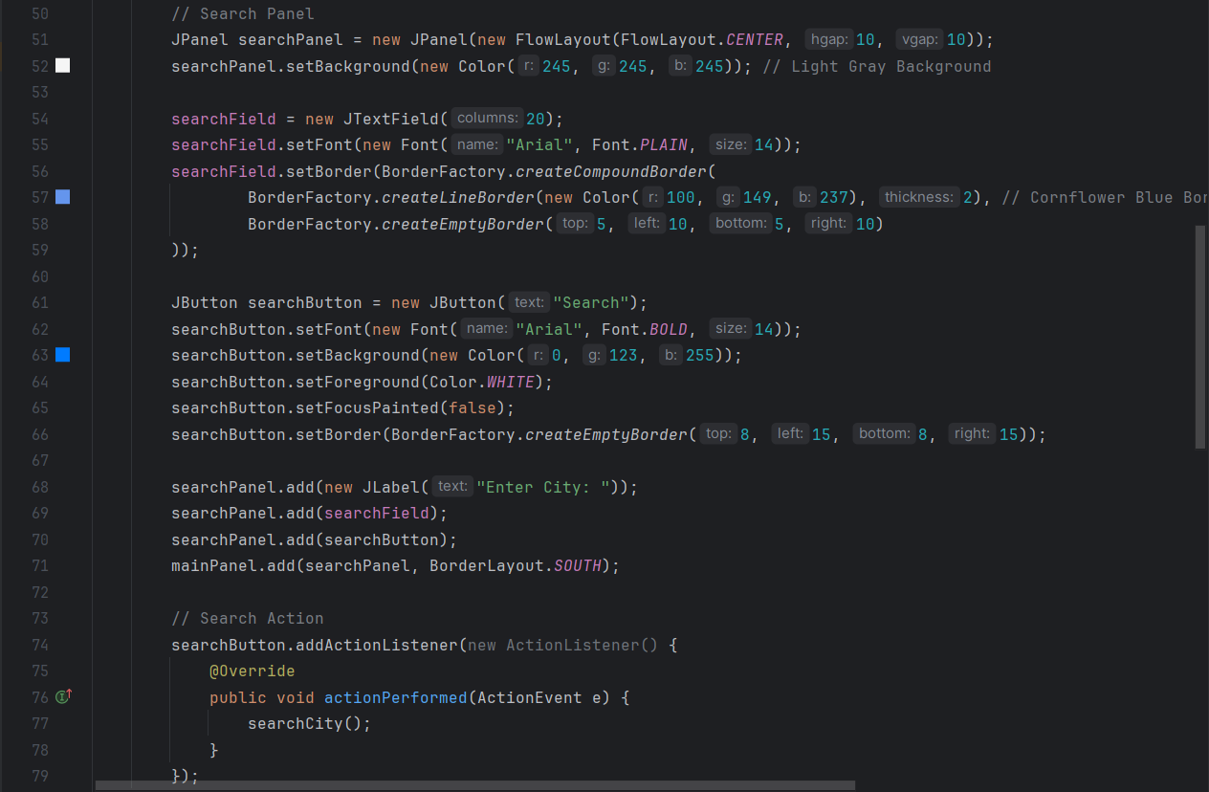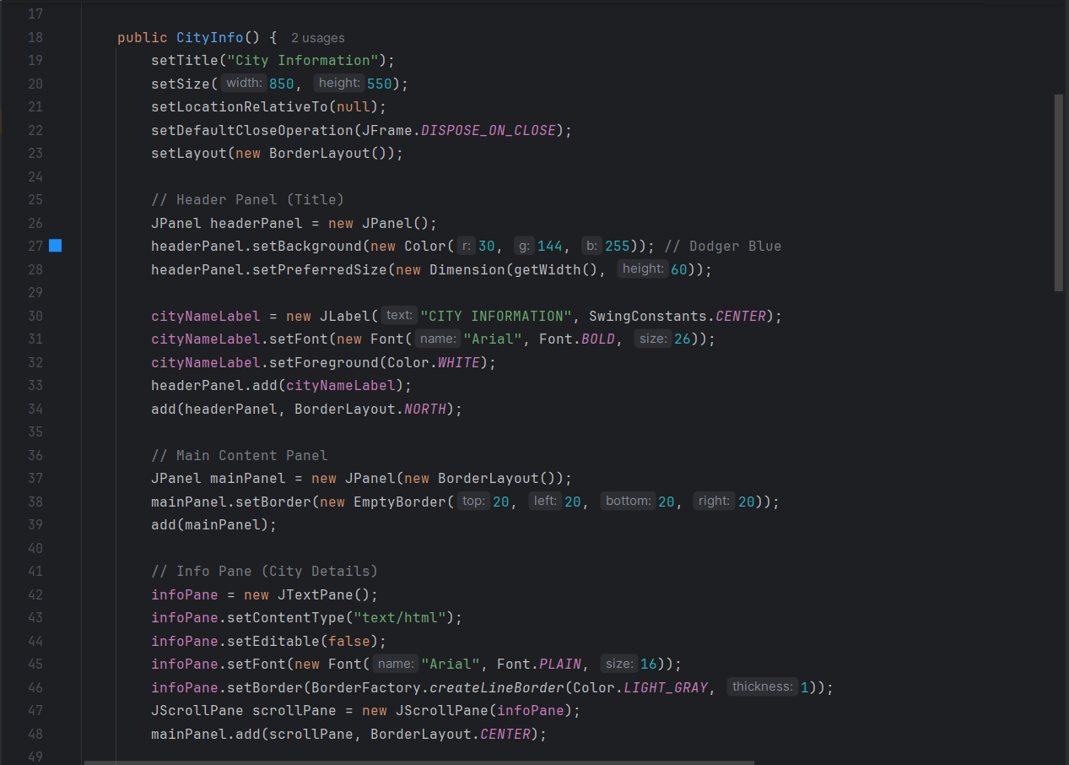

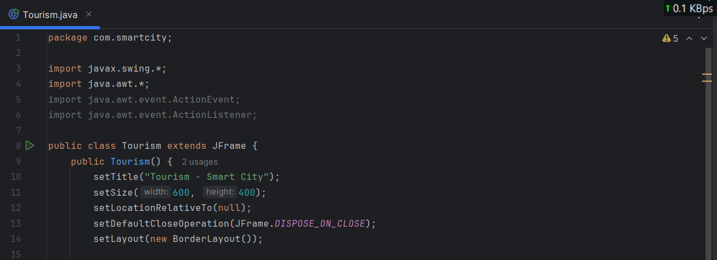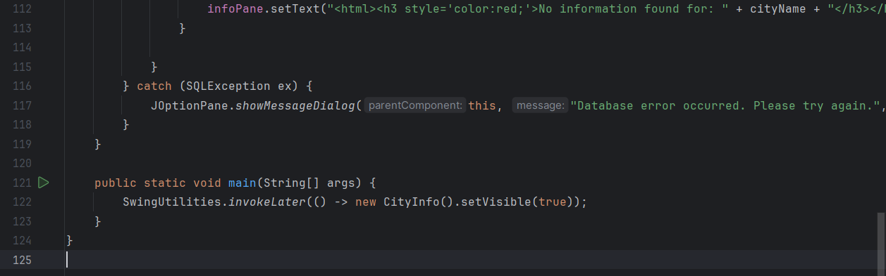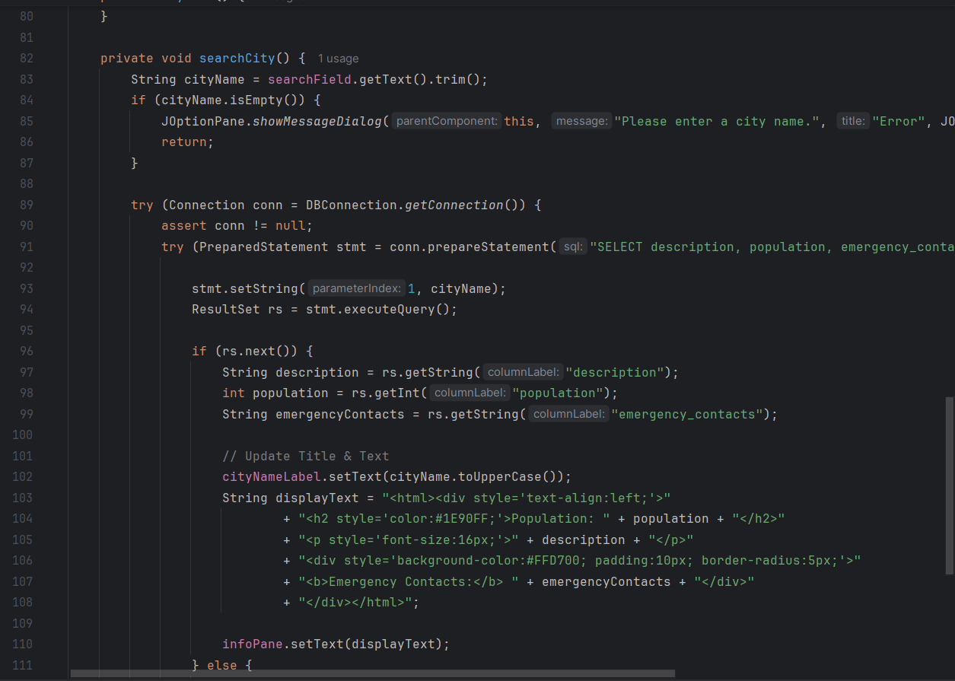

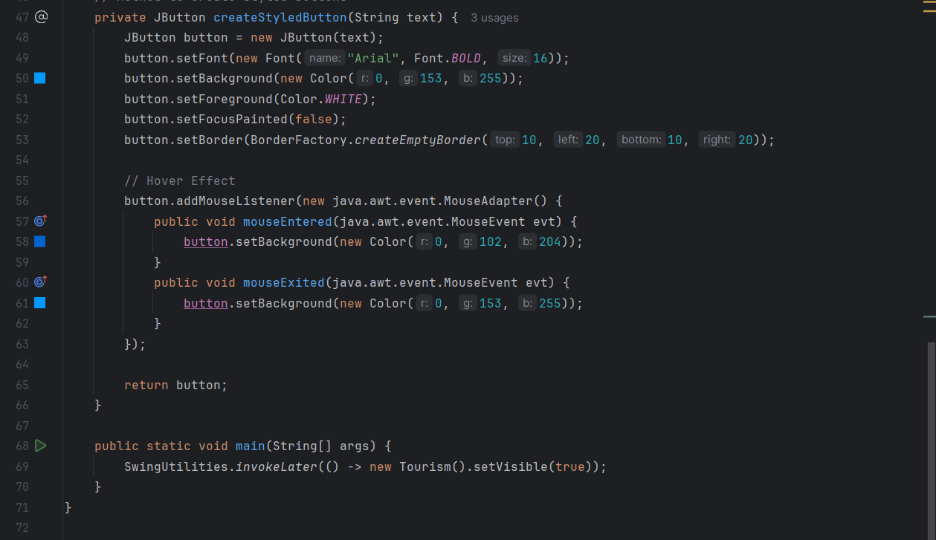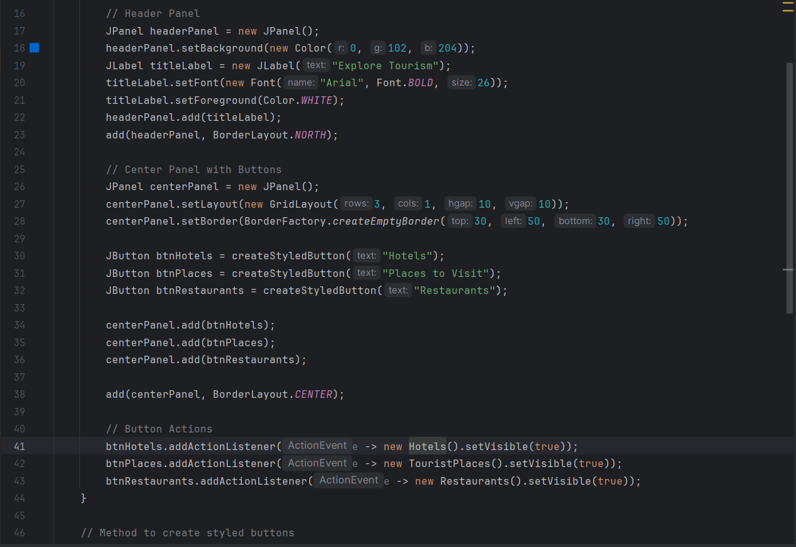

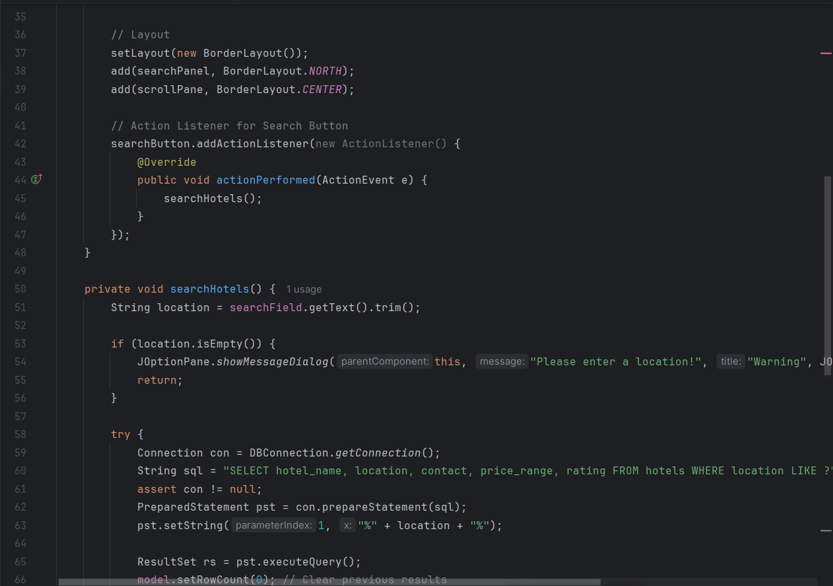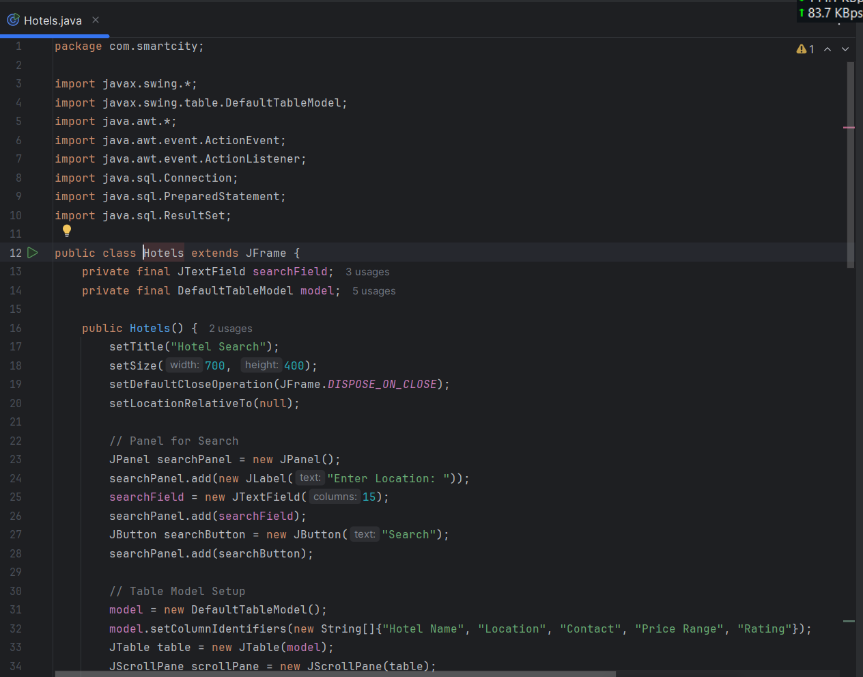

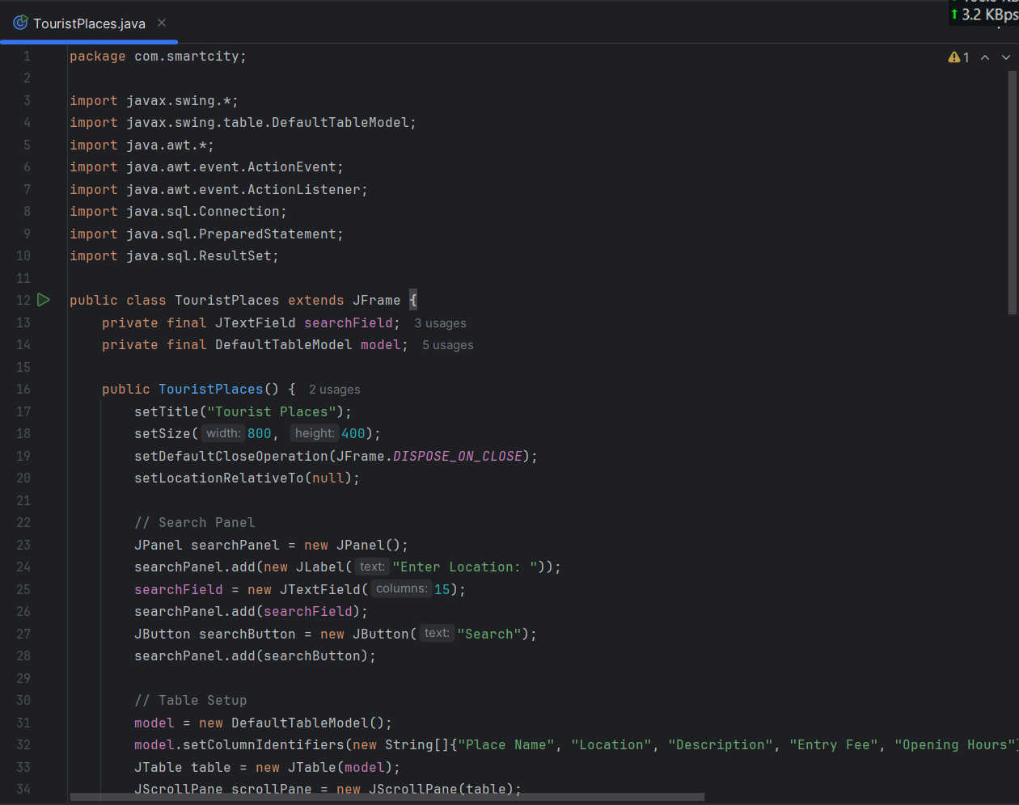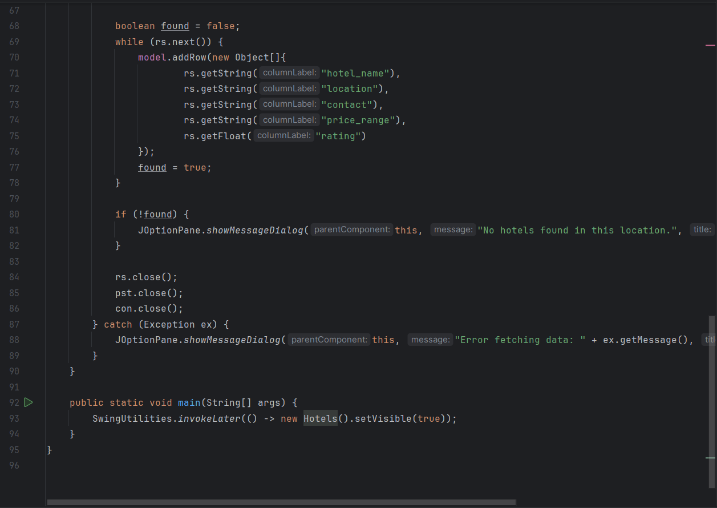

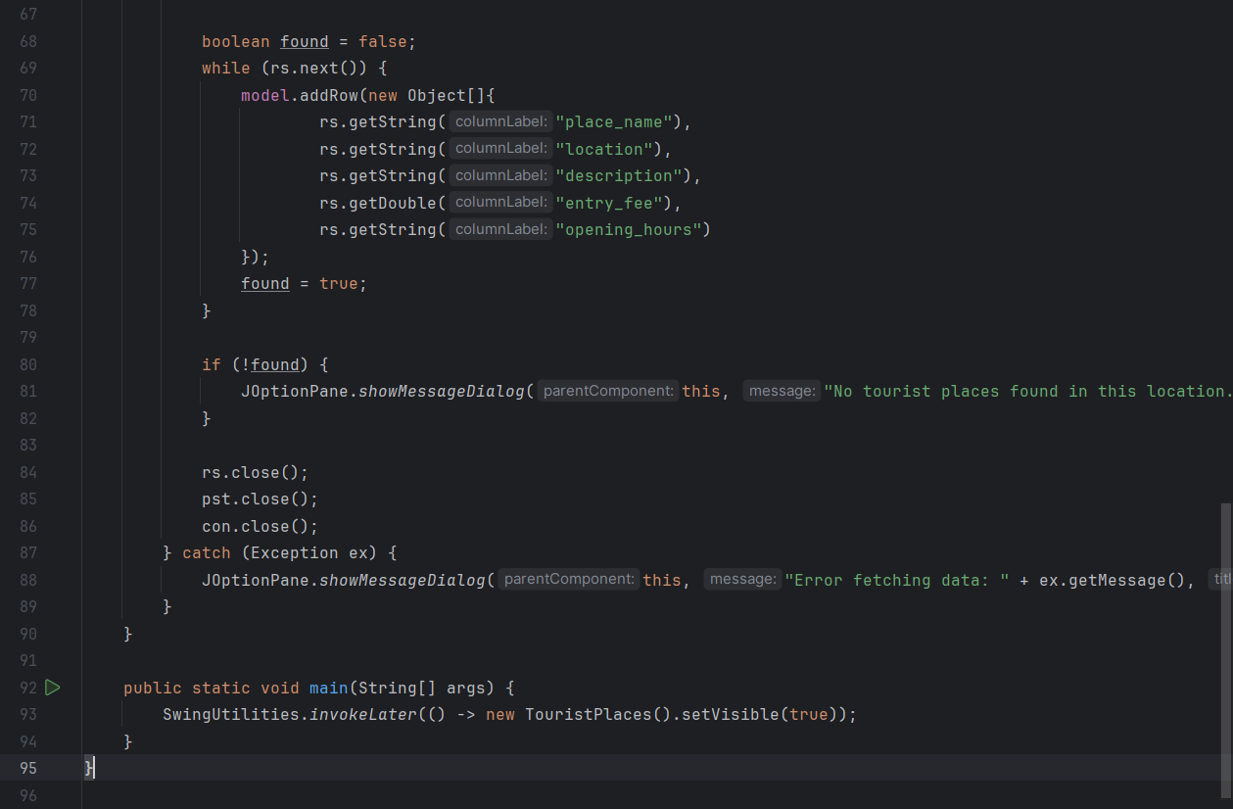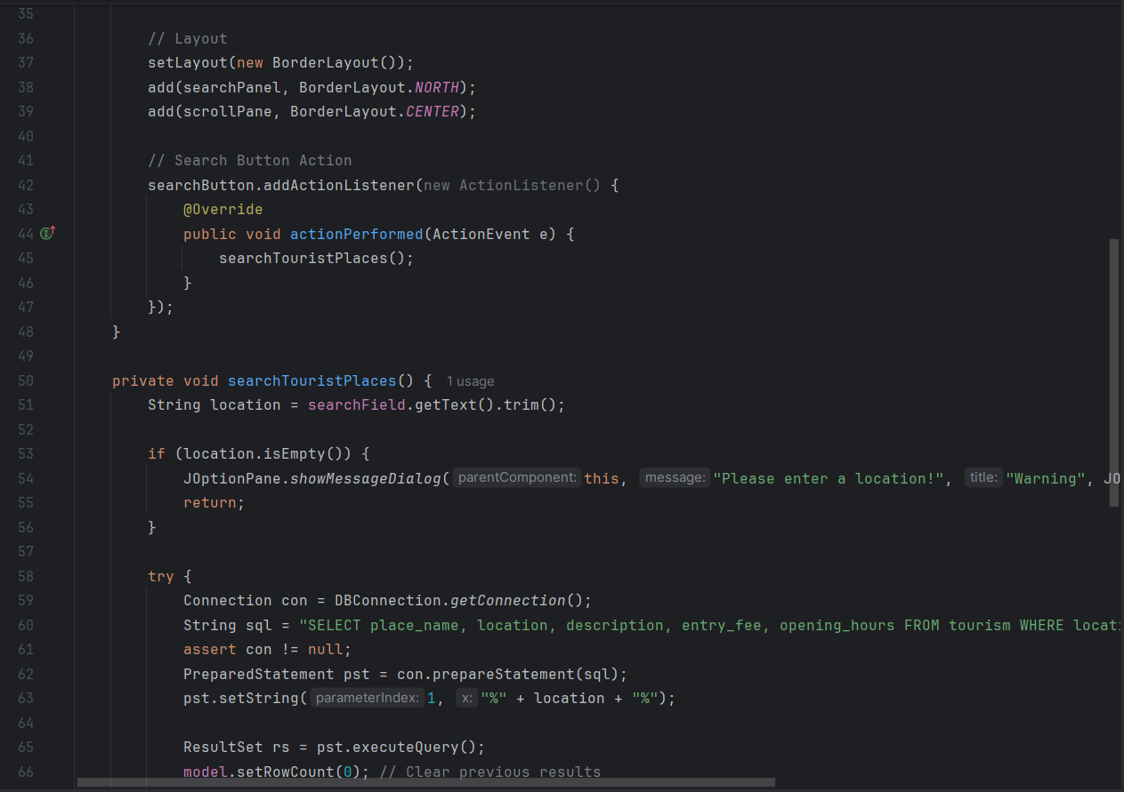

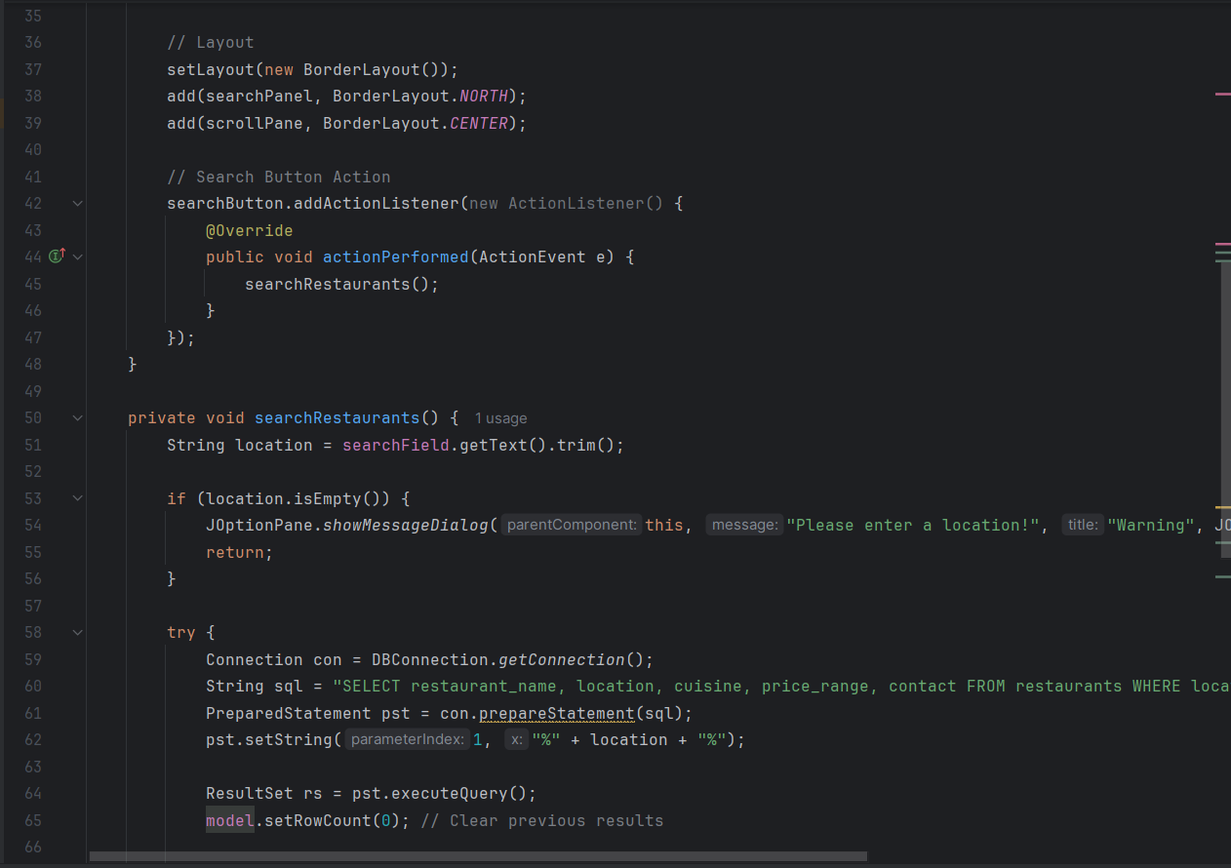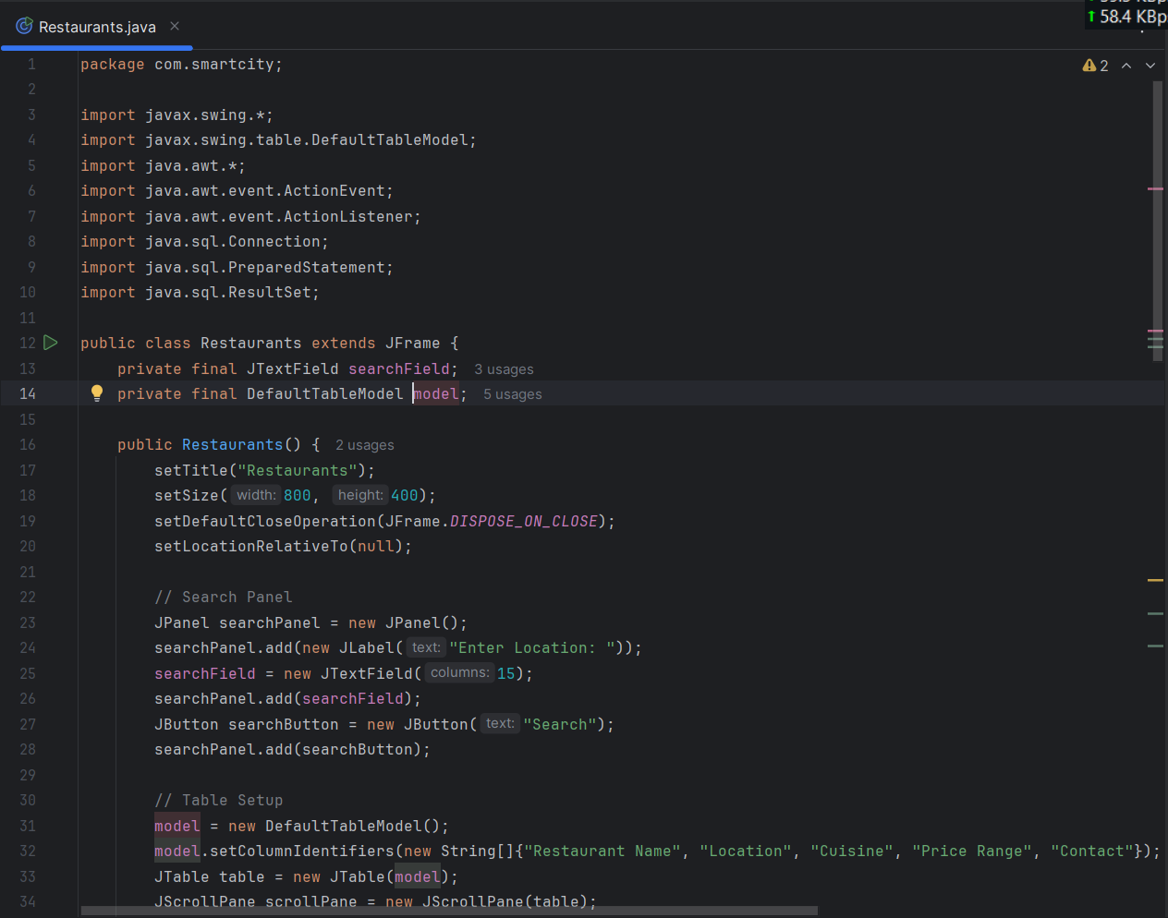

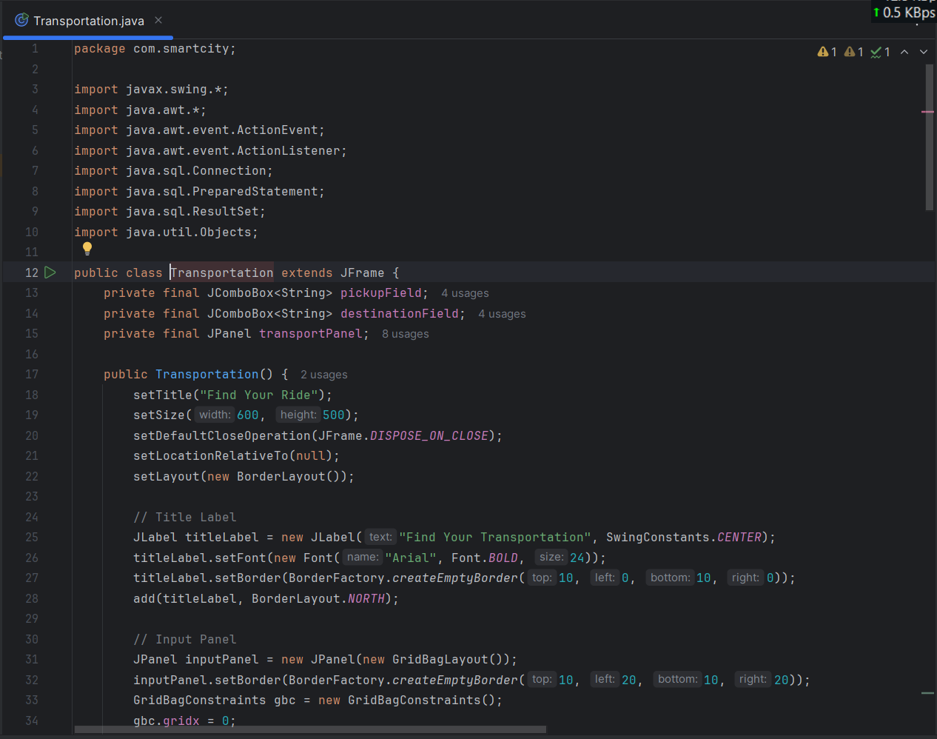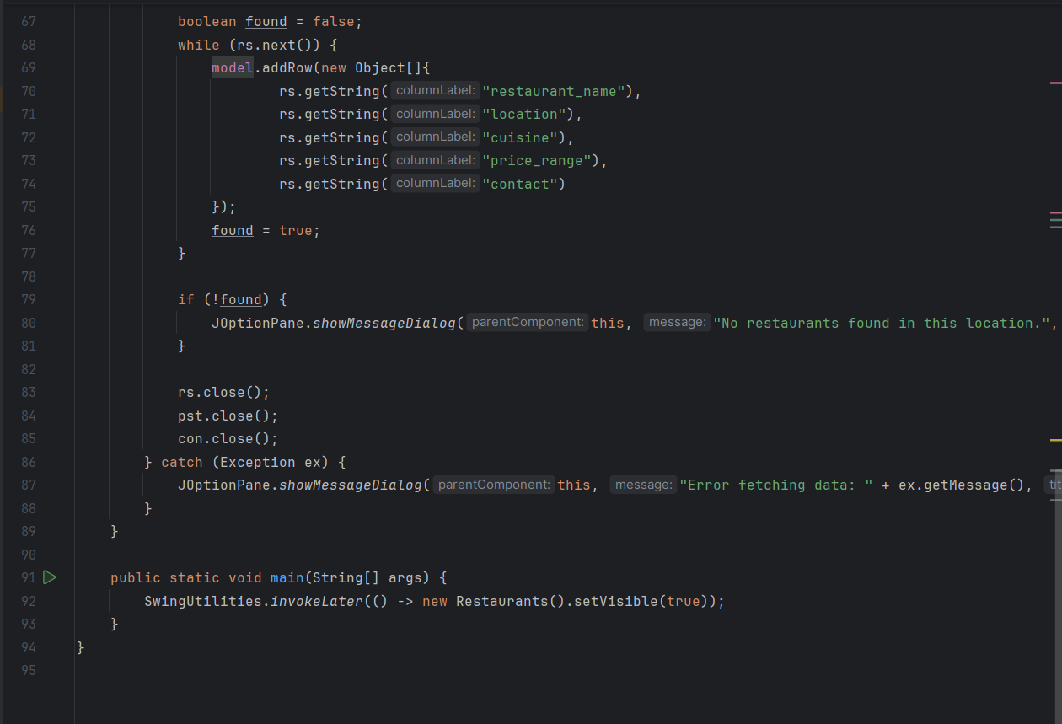

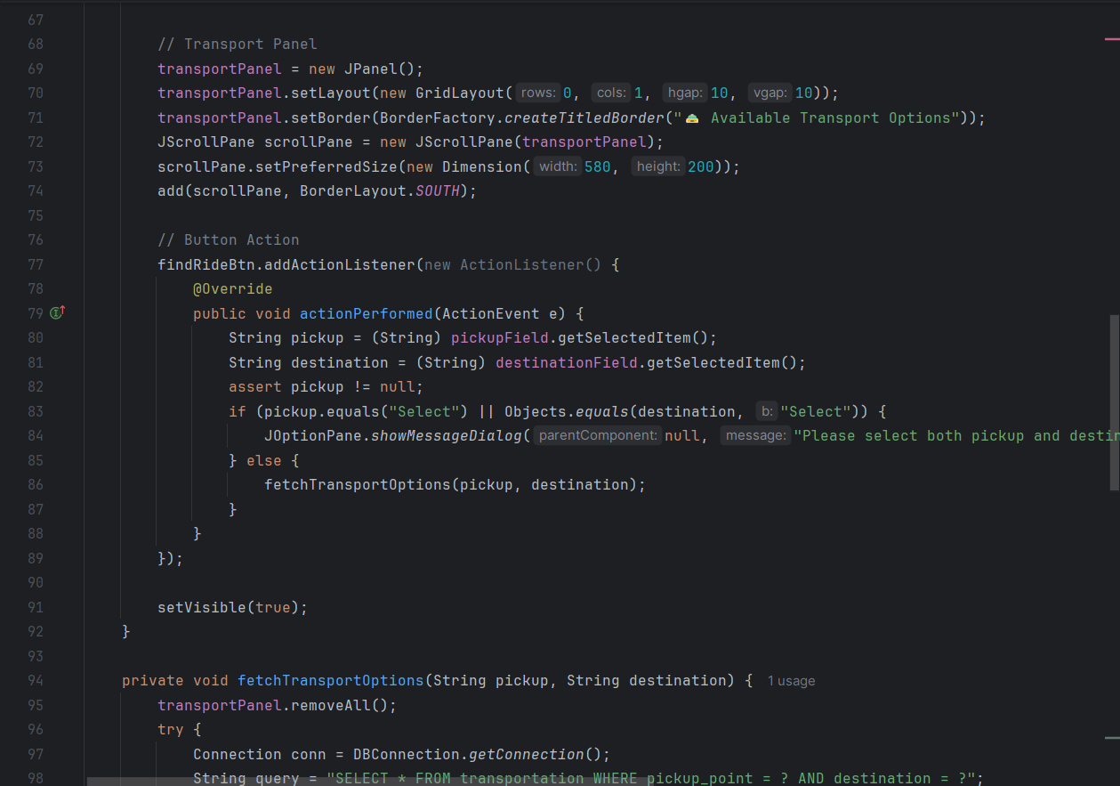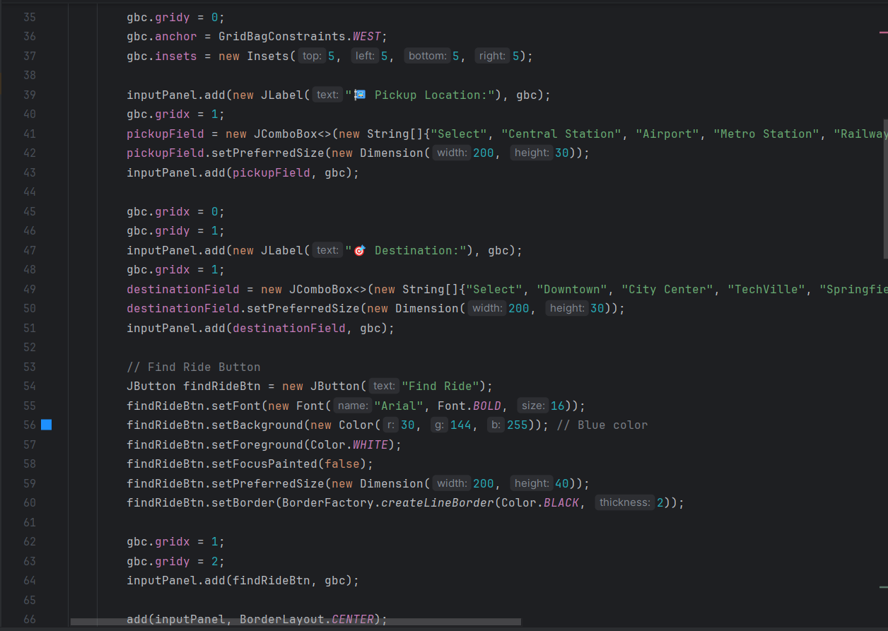

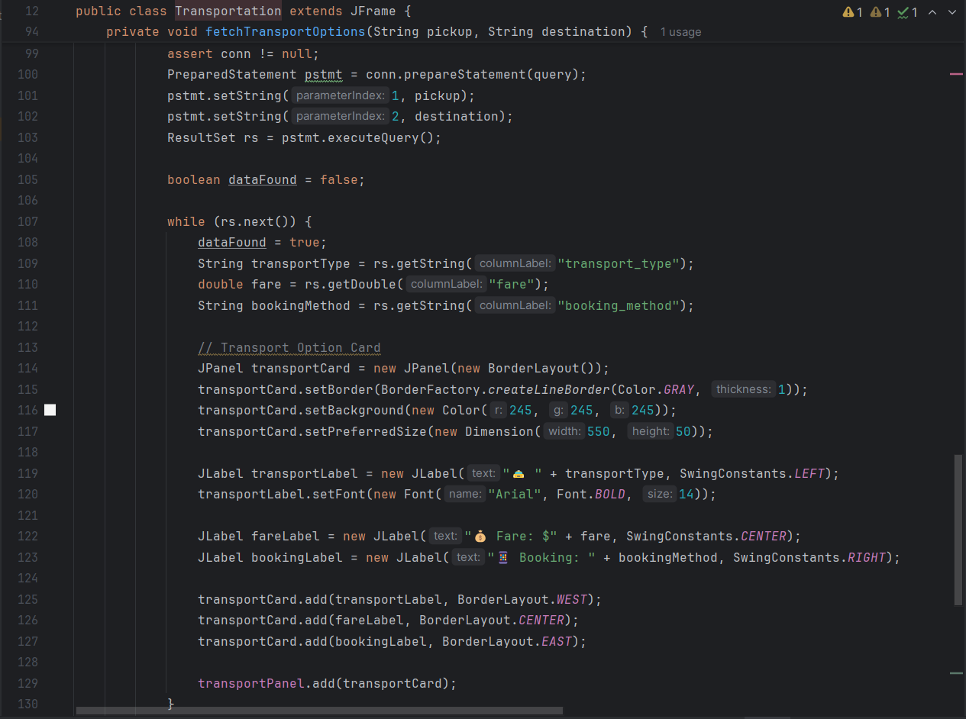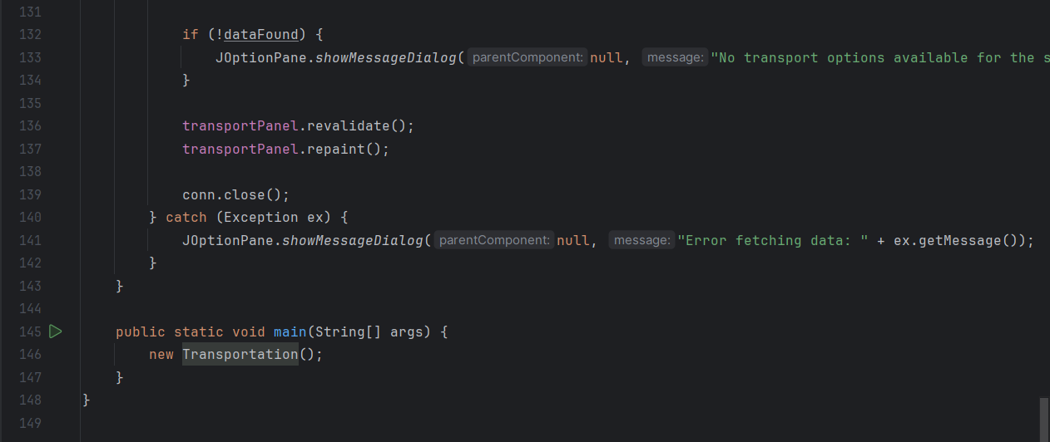

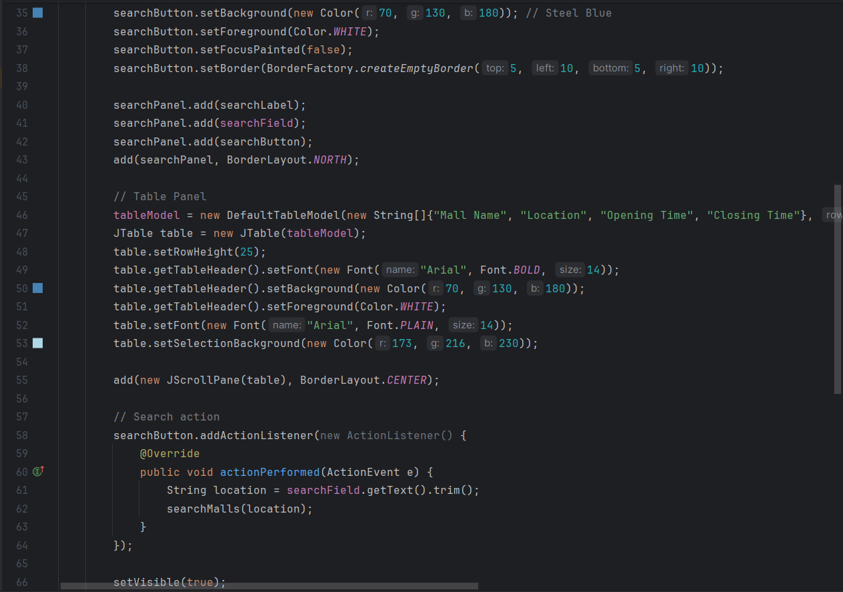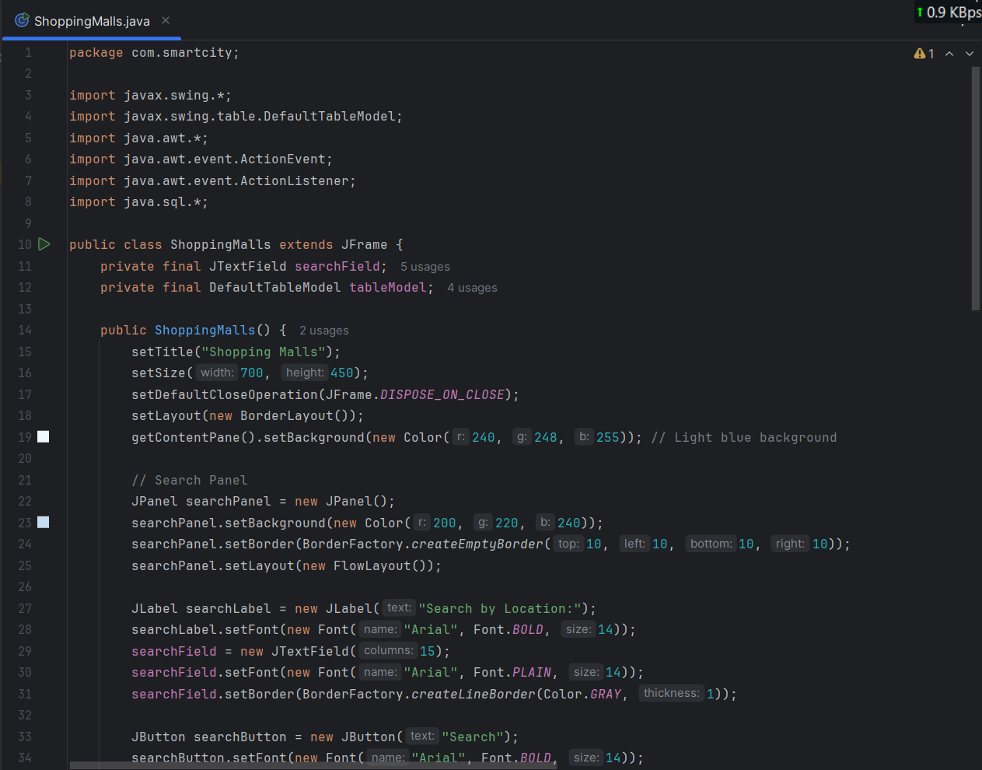

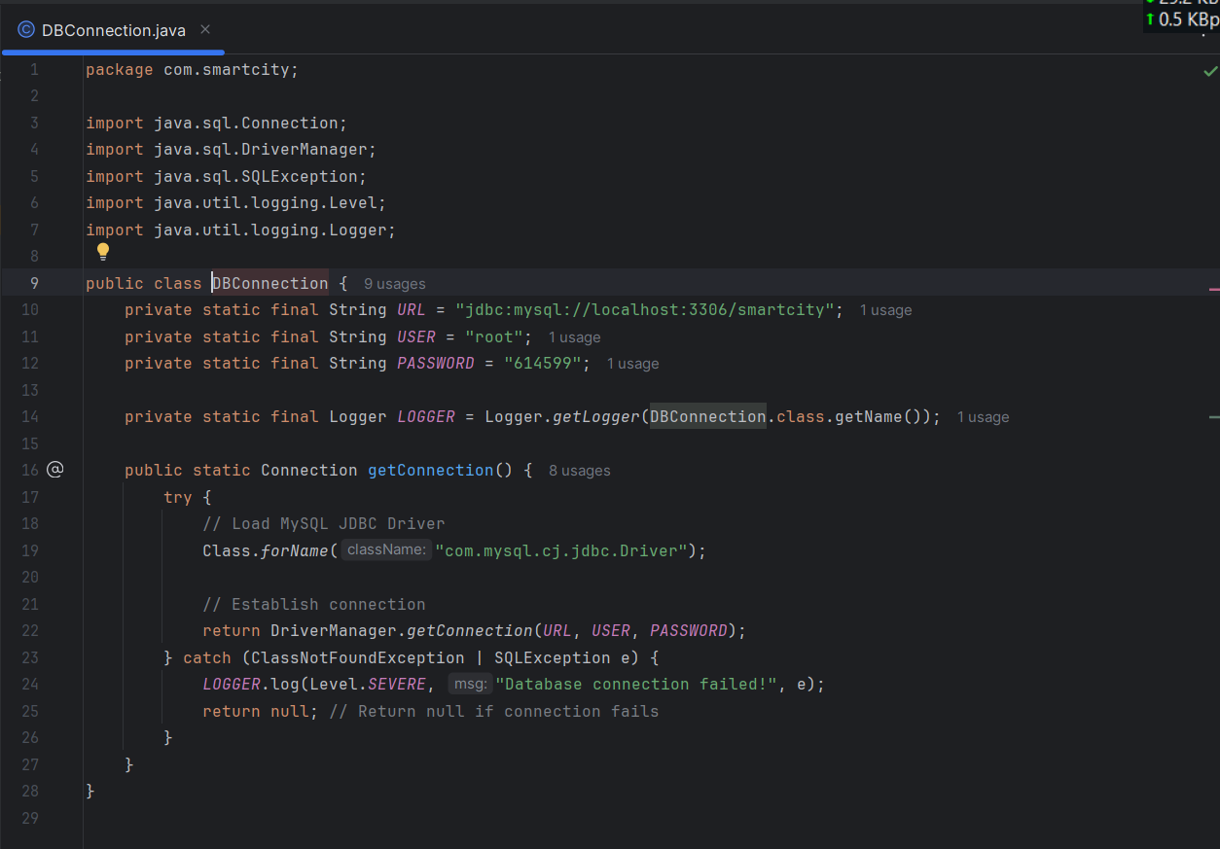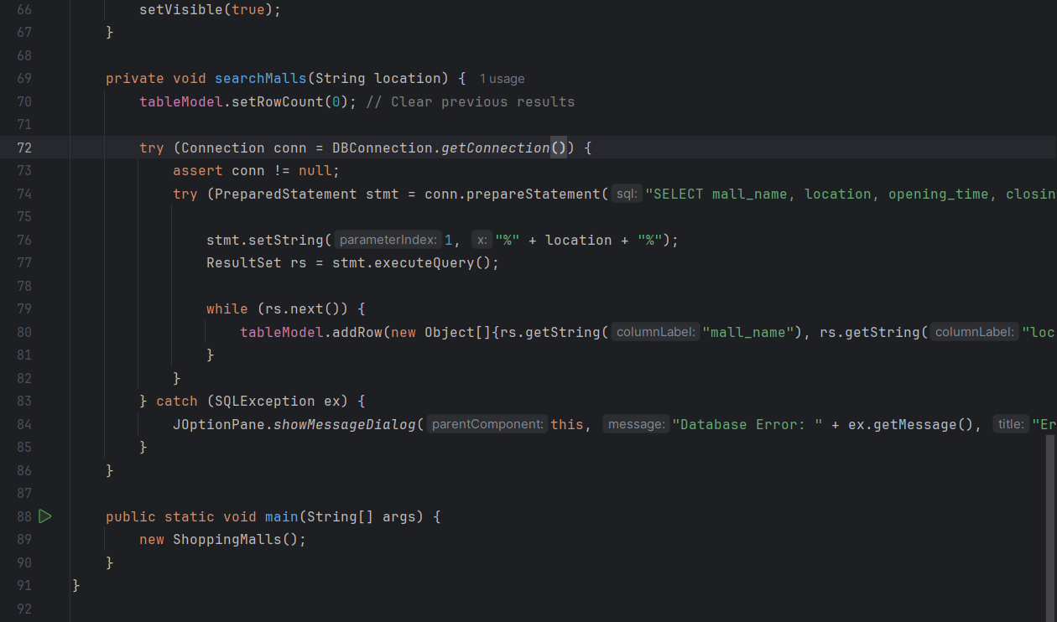

# 8. Output Screenshots

# 

# 

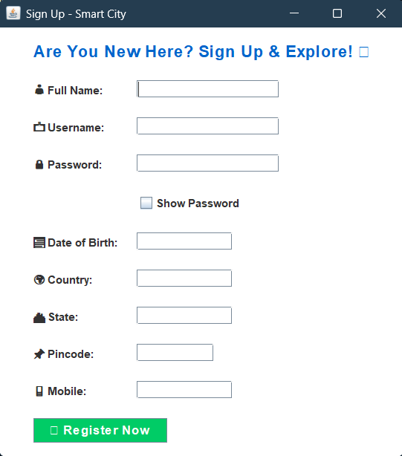

# 

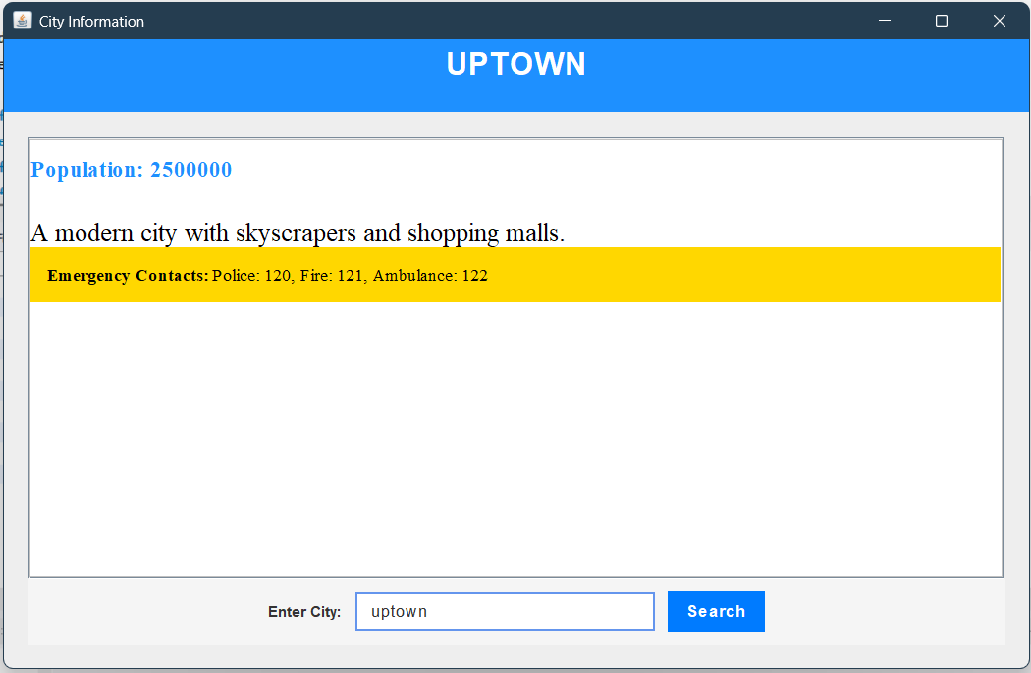

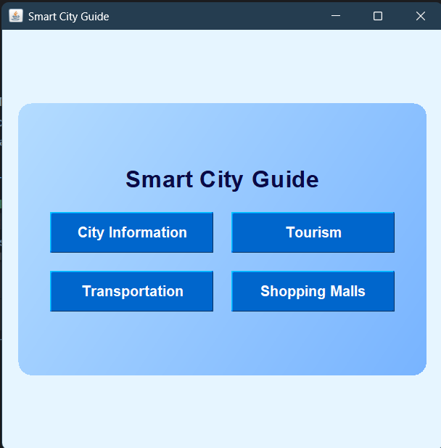

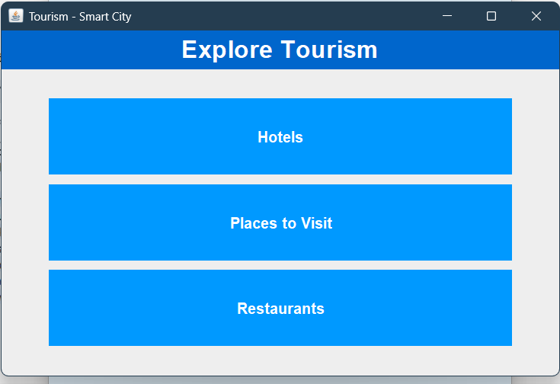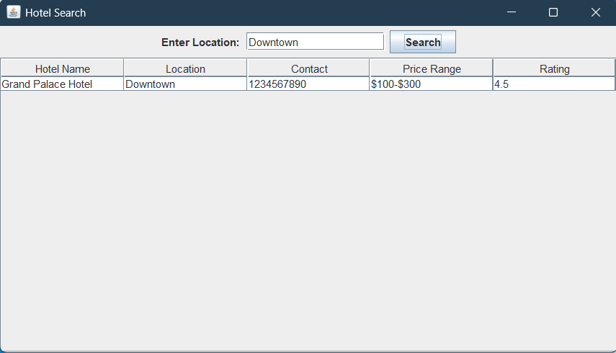

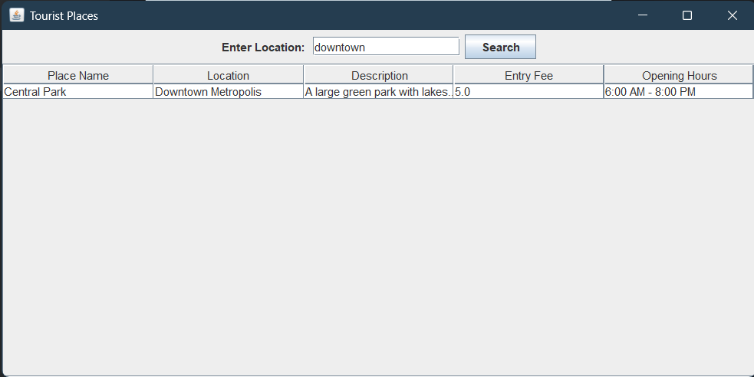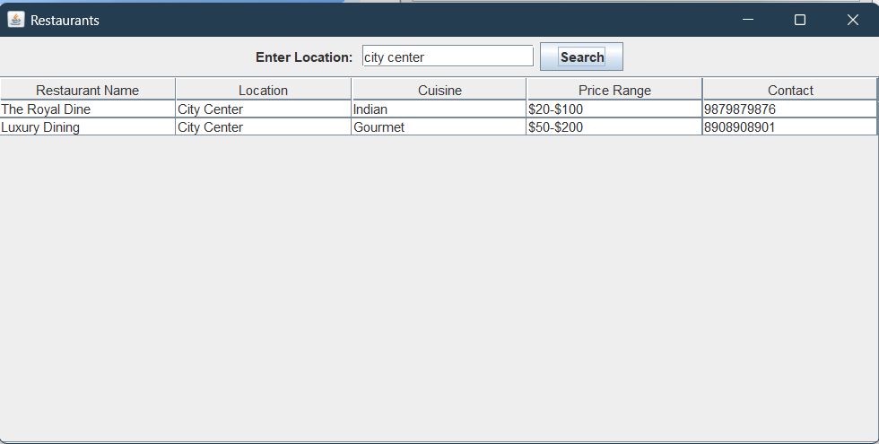

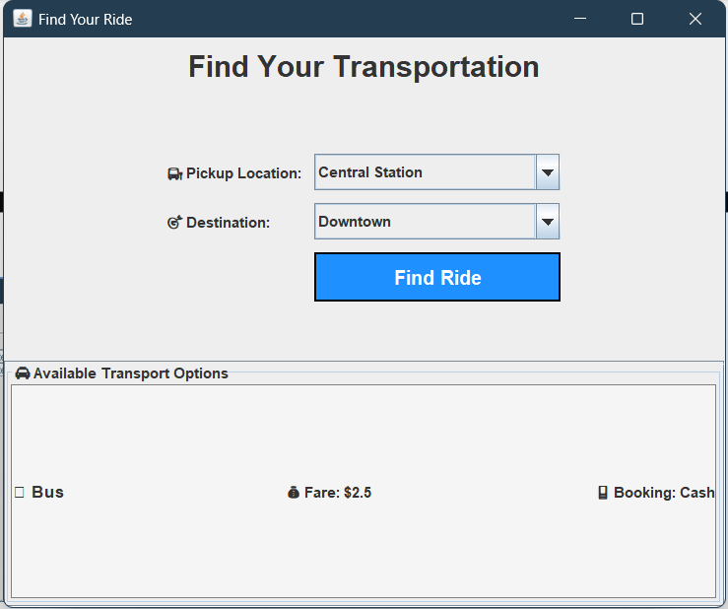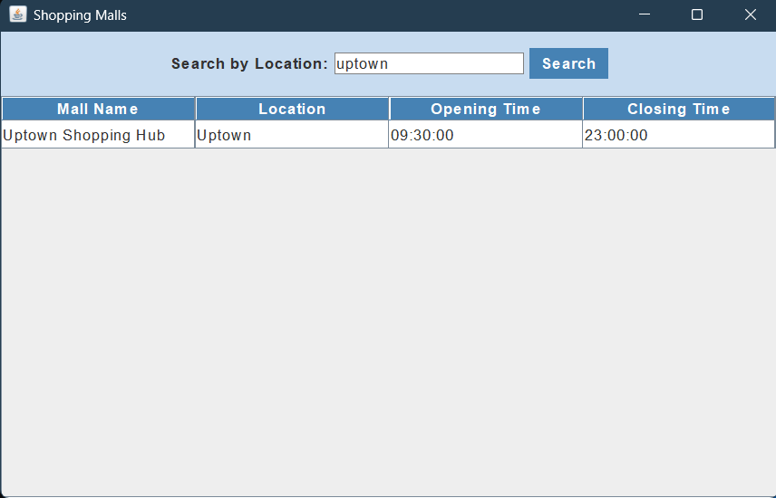

# 9. Project Summary

The Smart City Application successfully integrates city information, tourism, transportation, and shopping services into a single platform. The application is built using Java Swing and MySQL, allowing users to search for places dynamically. The enhanced UI design, especially in the Transportation section, provides an experience similar to modern ride-booking apps.

# 10. Important Learnings

During the development of this project, I gained valuable insights into:  
Java Swing UI Development  
MySQL Database Integration  
JDBC for Data Fetching  
Object-Oriented Programming (OOP) Concepts  
UI/UX Enhancement Techniques  
Designing an Interactive Transportation System

**Conclusion**

The **Smart City Guide Application** successfully provides an interactive platform for users to explore essential city services, including **tourism, transportation, hotels, restaurants, and shopping malls**. Through an intuitive Java Swing interface and a well-structured MySQL database, the application ensures smooth navigation and efficient data retrieval. Users can search for locations, view important details, and make informed decisions based on real-time information.

This project not only enhanced our understanding of **Object-Oriented Programming (OOP) in Java** but also provided hands-on experience in **database integration, UI design, and application development**. Future improvements may include **real-time booking options, user authentication, and advanced search features** to further enhance user engagement. Overall, this project serves as a solid foundation for building smart city solutions and improving urban navigation experiences.